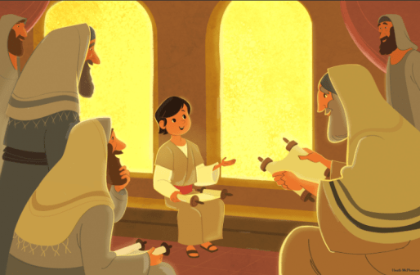
Boy Jesus in the temple
Luke 2: 41-52
This pack includes activities based on “Boy Jesus in the temple”, sourced from the internet, for children aged 3-6.
Activities include:
- https://www.youtube.com/watch?v=T908tgPIHFc Short version of Boy Jesus in the temple story on YouTube
- Bible story – Draw a picture of boy Jesus in the temple.
- Story telling activity
- Colouring Sheets

Tell the story using the pictured motions (keywords in bold)
Ask children to tell their ages. Every year you grow taller and stronger! Let’s hear what happened when Jesus was growing up.
Mary, Joseph and Jesus were living in Egypt. One night, God told Joseph, “It is safe to take Mary and Jesus home now.” They packed their things and walked to their own town of Nazareth. Joseph was a carpenter. Carpenters use tools and nails to make chairs, tables and other things from wood. As Jesus grew, He probably learned to use a hammer. He probably cut wood with a saw.
Jesus helped Joseph make things out of wood. Every year many people travelled to worship God at the Temple in Jerusalem. When Jesus was 12 years old, His family travelled to the Temple, too. Many families walked together to go to the Temple.
Mary, Joseph and Jesus could see the beautiful Temple. They were glad! Many people prayed and sang glad songs to God at the Temple. They listened to God’s Word. They ate special meals and talked to their friends.
Then the visit was over. Many people were walking home with Jesus’ family. Joseph and Mary thought Jesus was walking with their friends. But Jesus wasn’t! Jesus was still in Jerusalem!
When everyone stopped for the night, Joseph and Mary looked for Jesus. They couldn’t find Him! Joseph and Mary began to worry. They asked everyone, “Where’s Jesus?” No one knew where Jesus was. Mary and Joseph hurried back to Jerusalem. They asked everyone they saw if they had seen Jesus!
Mary and Joseph went to the big Temple. There was Jesus! He was talking with the Bible teachers! He wasn’t afraid. He knew God loved Him. Joseph and Mary were glad to find Jesus! They took Jesus back home. They took care of Him. Jesus grew and learned, just as God had planned.
Talk About the Story Where did Mary and Joseph find Jesus in Jerusalem? (In the Temple.) Jesus was growing up. He went to the Temple to talk with the teachers about God. We can learn about God as we grow, too. What are some ways we can learn about God?
Draw a picture of boy Jesus in the temple.

Draw a small room or building outline on sheets of construction paper, one for each child. Each child glues circle faces onto his or her own sheet of construction paper.

http://storage.cloversites.com/waipunachapel/documents/Lesson%2018.pdf
Construction Centre: Block Temple
Collect: Bible, building blocks, several cardboard paper towel tubes, a sheet of poster board, toy people.
Do :
1. Children build a big building with blocks. Children use paper towel rolls as columns and place the poster board on top as a roof.
2. Children use toy people to show Mary, Joseph and Jesus walking to the Temple, Mary and Joseph walking away from the Temple, searching for Jesus, and then finding Jesus in the Temple.
http://storage.cloversites.com/waipunachapel/documents/Lesson%2018.pdf
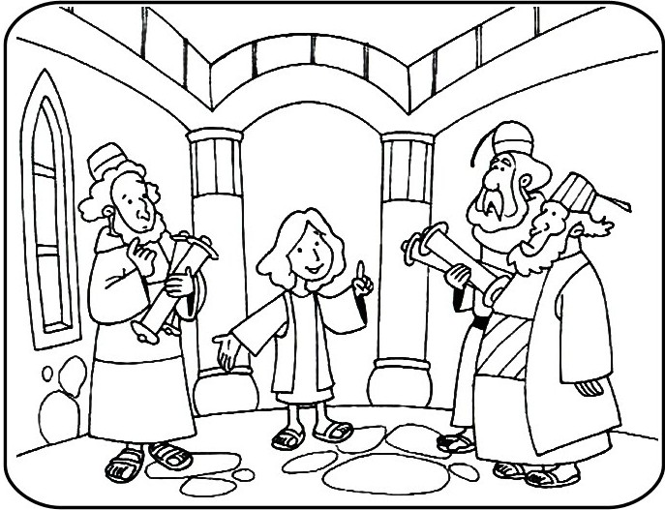
https://www.clipart.email/clipart/jesus-in-the-temple-clipart-35371.html
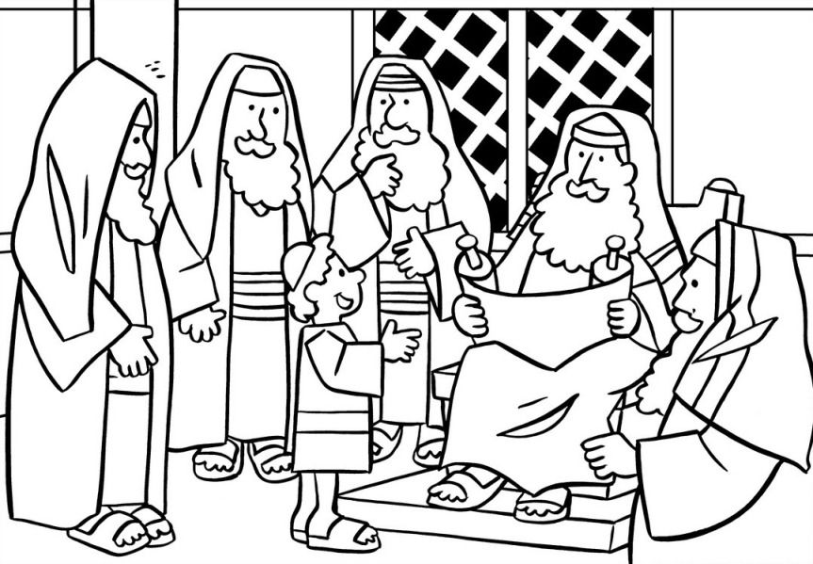
https://www.pinterest.co.uk/pin/271834527486483367/?nic_v1=1a7hl87hb3lDeyKZZSbVJKiE5zR9L2oiGNSq%2B5CZcm1AnCksPdP3FAsZBrzBv5Z00O

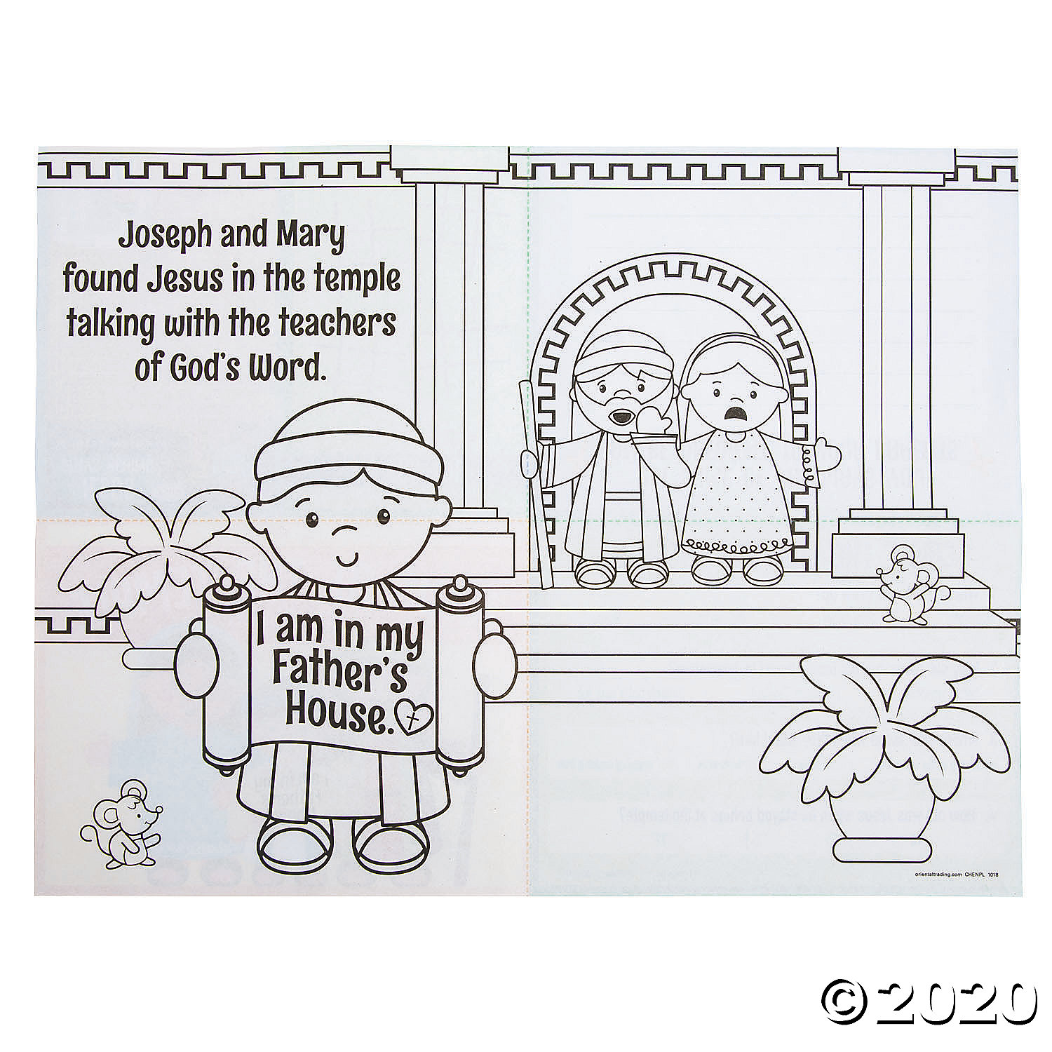
https://www.orientaltrading.com/jesus-at-the-temple-activity-sheets-a2-13830695.fltr

